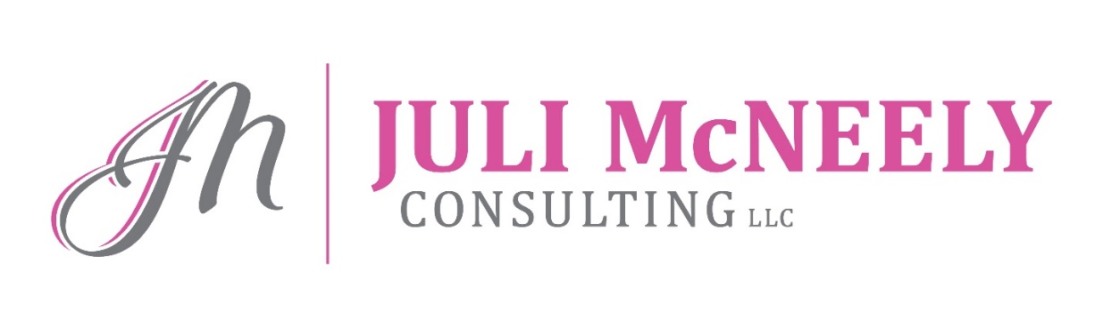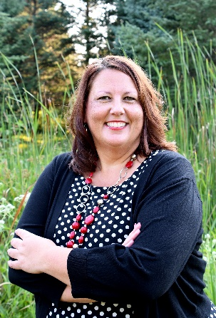

No Necktie Needed
Ladies…….does someone else define and measure success for you? Shouldn’t you decide what gives your life purpose? You are a highly valued part of an industry that lets you use the skills and attributes that come naturally to you as a woman to earn an exceptional living and spend ample time with your family – all by helping others find more security and greater peace of mind for theirs. Juli will share her experiences of over two decades as a financial advisor and owner of McNeely Financial Services, Spencer, Wisconsin. No Necktie Needed will show you that the sky is the limit!

Success on PURPOSE
How do you define success and when do you know when you have found it? Juli discusses those defining moments and lessons learned that have shaped her own success and have allowed her to continually evolve her own definition. You’ll leave this session asking yourself “what’s next for me?” Success looks different for everyone. Is it getting a designation or obtaining a certain level of production? Many believe that there are certain steps that must be taken in order to be “successful” in our industry. Success is more than obtaining goals. Setting and striving to reach our goals is essential but merely obtaining a designation or a certain level of production doesn’t necessarily mean you are successful. It is about touching lives, making a difference and appreciating what we have. The talk appeals to all career stages – young advisors to transitioning seasoned advisors.

Habit + Process = SUCCESS
Juli shares some success principles as well as some pertinent practice management ideas/sales ideas that have allowed her to find success in her own practice. As advisors, we often get stuck in our old ways. Juli will share how at McNeely Financial Services the team works together and explores new ways to approach serving clients. The way we run our practices is changing and consumers are changing. Will you keep up? Will you evolve?

Closing the Gender Confidence Gap
What makes you feel more confident? Does your gender play a part in how confident you are? This session will help you understand the gap between men and women when it comes to confidence but more importantly it will help you take that knowledge to help connect with your clients regardless of gender to ultimately help grow their financial confidence. After all….isn’t that what we all want? To feel confident ourselves and connect on a deeper level with our clients so they can feel confident in the decisions they are making.

Strategic Team Workshop
Is your entire team on board with the firm’s success goals? This session is designed to include the entire team and will include writing individual business plans to achieve cumulative firm results. Having the entire team part of the strategic process can only help obtain buy in and allow the firm to reach new heights. Consistent accountability also improves since each team member has listed their objectives for the year. It’s time to get your entire team working together to ensure everyone wins!!

Speaking Fees: Negotiated Individually

